We Accept Credit/Debit Cards
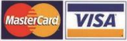
- Complete the order on the brochure order form and indicate “CC” as your payment method on the student’s order form.

- Pay now at www.paythankyou.com or scan the QR Code:

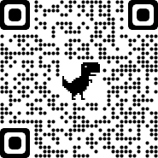

734267

- Enter the Organization ID

- Complete the fields and submit the payment. The supporter will receive a receipt via email.
- Thank you for paying the small service fee. This enables our school group to use the PayThankYou service at no charge.

Note: PROFIT PLUS INC will show as payee on your credit card statement for your fundraising purchase.

